Insight Generation & Recommendation Formulation  Report |  | Airline Performance  Intelligence✈️
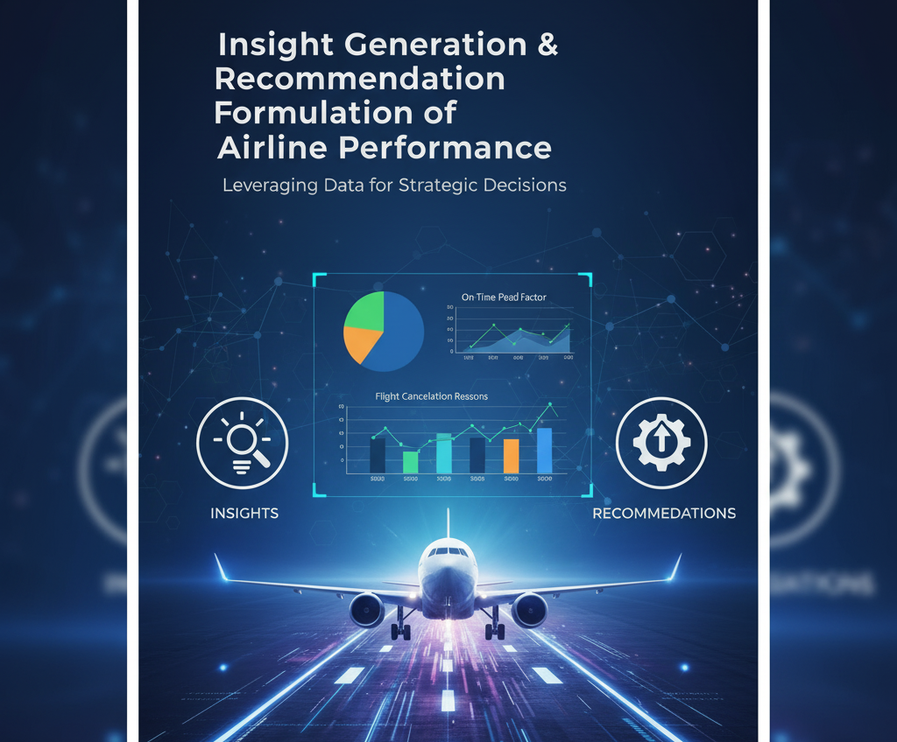
Date: October 8, 2025  Mohammad Faiz | Project: Airline Performance Intelligence Dashboard

Focus Area | Key Finding
Airline Performance | Bottom 3 for OTP: American Airlines (AA), United Airlines (UA), Frontier (F9). AA has the lowest OTP at 81.2%.
Delay Drivers | Late Aircraft Delay is the largest contributor (40%), followed by Airline Delay (35%). Weather accounts for only 10%.
Worst Performer (AA) | AA’s primary delay type is Late Aircraft Delay (55% of their total delay minutes), indicating turnaround inefficiency.
Airport Performance | Newark (EWR) and Chicago O’Hare (ORD) have the worst departure OTP. EWR’s average delay peaks at 70 mins during 6–9 PM.
Temporal Trends | Delays peak in July/August and on Mondays. February shows best performance.

Key Findings (Simulated Data)
2
analytical Insights  (The “Why?) | 
• American Airlines’ delay profile suggests internal operational inefficiencies, especially in aircraft readiness and gate turnaround.
• Late Aircraft delays dominate system-wide, indicating that cascading delays from previous flights are a major issue.
• Weather delays spike in Q3, particularly in Northeast hubs, due to seasonal storms and congestion.
• Monday delays may stem from weekend aircraft repositioning and crew fatigue.
• Evening delays at EWR and ORD reflect slot saturation and limited runway availability during peak hours.

Recommendations  (The “How to fix it”) | 

1. American Airlines (AA)

• Invest in gate turnaround optimization and aircraft readiness protocols.

• Use predictive maintenance and real-time crew coordination tools.

2. Q3 Weather Mitigation

• Deploy contingency staffing and rerouting protocols in Northeast hubs.

• Use historical weather data to preemptively adjust schedules.

3. Monday Delay Reduction

• Adjust crew rosters and aircraft rotations post-weekend to reduce fatigue-driven delays.

• Introduce buffer slots for high-risk routes.

4. EWR/ORD Optimization

• Collaborate with ATC for slot smoothing and gate reassignment.
• Consider staggered departure windows to reduce congestion.

CONCLUSION
This project demonstrates how data-driven dashboards can reveal operational bottlenecks and guide strategic decisions. The insights and recommendations are designed to help airlines and airport authorities improve punctuality, resource allocation, and passenger experience.

